
Godalming Art Space

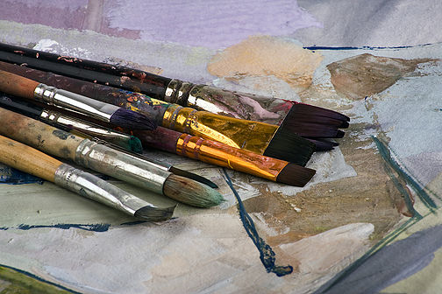
Saturdays at Godalming Baptist Church
Queen Street, Godalming, GU7 1BA

Dates for 2020

January 11th February 1st March 14th
April 4th May 2nd June 6th
July 4th September 5th October 3rd
November 7th December 5th

We meet from 9.00am - 12.30
Feel free to join us any time during the morning.
Please bring any materials you would like to work with.

This is not a teaching morning but purely a great opportunity to lose yourself in creativity for a few hours.

If you would like more information please contact;
Church Office: 01483 422105 Mon, Weds and Friday mornings
OR E-mail Sally Pollard: pollard3@hotmail.co.uk

